KWAME NKRUMAH UNIVERSITY OF SCIENCE AND TECHNOLOGY

COLLEGE OF ENGINEERING

DEPARTMENT OF CHEMICAL ENGINEERING

TITLE: DENSITY, STATISTICAL ANALYSIS OF DATA, GRAPHICAL DATA ANALYSIS AND SPREADSHEET DEMONSTRATION



NAME: DADZIE QUAINOO VINCENT

COURSE: BSC.PETROCHEMICAL ENGINEERING

YEAR: FIRST YEAR

EXPERIMENT NO. : A.1.1.1.

I.D. NO: 20364090

DEMOSTRATOR: EMMANUEL AGYEMANG DUAH
DATE: 15TH OCTOBER, 2014

Aims and Objectives:
- To practice the use of the analytical balance.
- To gain experience with different methods of measuring the volumes of regular and irregularly shaped objects.
- To gain understanding of the concept of density and its evaluation.
- To use a graphical approach to data collection.
- To apply statistical analysis to data collection.
- To observe the use of a computer spreadsheet for calculation and data analysis.

INTRODUCTION
The purpose of the experiment is to use three different methods to determine the volume of regular and irregular objects and hence density.

It is defined as the ratio of mass of a substance to its volume. It therefore gives an idea about how matter is spread over a given volume. The mass of a substance (body) is defined as the amount contained in that substance and it is accurately determined with either an analytical balance or digital balance and this is done accurately. It standard unit of measurement is grams (g), however in dimension analysis it is denoted as M.

Volume is the space occupied by matter in an object. The volume of a substance is determined by using a measuring graduated cylinder or eureka can. For the graduate measuring cylinder, the volume of a substance is calculated directly from the change in water levels but for eureka can when a substance is suspended into it, the change in volume is equal to the displaced water. This method is used to determine the volume of irregularly shaped objects. However, the volume of regular objects is determined by finding the product of the dimensions. That is:

Volume (V) = length (l) x breadth (b) x height (h)
Or Volume (V) = π (l) x [radius (r)]² x height (h)
Or Volume (V) = (length) ³
The standard unit for volume is cubic centimetre (cm³) or millimetre (ml).
Density is a very important parameter which does not depend on the shape of the body whose density is being determined. In the experiment, data is collected to determine the density of objects using three different methods.
Mathematically:
Density ( ) = mass (m)g
Volume (v) ml

The first method involves determining the mass of the object with an analytical balance. The dimensions are then measured in centimetres and the volume is calculated using a relevant formula depending on the shape of the object i.e. V = L x B x H. The ratio of the mass to the volume gives the density.

The second method involves determining the volume of the object from three weighing and the density of water. One of the wooden objects is placed in a preweighed 25ml graduated cylinder and weighed. Sufficient water is added to cover the object to an accurately measured volume mark and obtain the mass of the cylinder, object and water.

The final method employs water displacement in the determination of the volume of the object. Water is place to an accurately known level in a graduated cylinder and the wooden object is carefully lowered into it. Because wood is less dense than water, it will float and will again have to be pushed and held below exact water level in the cylinder. The displaced water volume is the volume of the wooden object. The density is then given by the mass to volume ratio.

CHEMICALS AND EQUIPMENT
Analytical balance 4 wooden objects A, B, C, D
A 50ml volumetric flask 5.0g of NaCl crystals
Beaker N-butanol solution
Graduated cylinder Distilled water
A wash bottle Broomstick

PROCEDURE

A. DETERMINING THE DENSITY OF OBJECTS WITH THEIR DIMENSIONS
- 4 wooden objects namely; A, B, C, and D of the same colour, different shapes and different sizes where selected.
- For each piece of wood, the mass was accurately weighed on an analytical balance and recorded.
- The dimensions for each piece of wood were measured using a ruler and recorded.
- For each piece of wood, the volume in cm³ was calculated as well as the density and was recorded.

B. DETERMINING THE DENSITY OF OBJECTS FROM THREE WEIGHINGS AND THE KNOWN DENSITY OF WATER.
The densities of the same four objects were determined using the following three mass determinations:
- the empty dry 25ml graduated cylinder,
- the cylinder with an object in it, and
- the cylinder, wooden objects and water filled to an accurately measured volume.
The masses of the various wooden objects were determined with the analytical balance.

C. DETERMINING THE DENSITY OF OBJECTS BY WATER DISPLACEMENT
- The masses of the various wooden objects were determined with an analytical balance.
- The respective volumes for objects A, B, C and D were determined by submerging each piece of wooden object in an amount of water in the graduated cylinder whiles recording the initial and final volume readings.
- The change in volume was then calculated by taking the difference of the final and initial readings.
- The wooden objects used were dried.

D. DETERMINING THE DENSITY OF CRYSTAL SODIUM CHLORIDE.
- A clean, dry, empty 50.0ml volumetric flask was weighed using an analytical balance and recorded.
- 5.0g of crystalline NaCl was added to the volumetric flask and was accurately measured.
- Sufficient n-butanol was added to cover the NaCl in the flask.
- The flask was then swirled, shaken and stirred until all the air bubbles trapped within the NaCl were dislodged.
- It was filled to the 50.0ml mark with n-butanol and then weighed.
- The mixture was then decanted by pouring the n-butanol covering the NaCl into the large beaker in the laboratory for recycling. As much NaCl was dumped into the other large beaker.
- the volumetric flask was washed and allowed to dried

TABLE OF VALUES

Method 1
Objects | L/cm | B/cm | H/cm | Mass/g | Volume/ml | Density/gcm⁻³
A | 1.60 | 1.10 | 1.10 | 1.15 | 1.939
B |  |  | 4.90 | 4.36 | 4.657
C | 4.30 | 1.10 | 1.10 | 3.16 | 5.230

Method 2
Mass of empty dry cylinder, M₀ = 46.72g
Mass of the cylinder + wooden object = M₁
Mass of the cylinder + wooden object + water filled to an accurate level = M₂
Volume of the water = V_{H2O}
Volume of object = V₀
Mass of wooden object = M₁-M₀
Mass of water = M₂-M₁

Objects | M₁ /g | M₂/g | (M₁ - M_{o})/g | (M₂ – M₁)/g | VH₂O/(cm³) | V₁/(cm³) | Density/gcm⁻³
A | 1.15 | 54.20 | 1.26 | 23.22 | 23.22 | 1.78 | 0.71
B | 31.04 | 54.38 | 1.32 | 23.34 | 23.34 | 1.66 | 0.80
C | 30.85 | 54.28 | 1.13 | 23.43 | 23.43 | 1.57 | 0.72
D | 33.23 | 54.22 | 3.51 | 20.99 | 20.99 | 4.01 | 0.88
E | 31.54 | 54.25 | 1.82 | 22.71 | 22.71 | 2.29 | 0.79

Method 3
Objects | Mass of Objects | Initial Volume(V_{i})/ml | Final Volume(V_{f})/ml | Volume of Object(V₀)/ml | Density/gcm⁻³
A | 1.27 | 15.00 | 18.00 | 3.00 | 0.42
B | 1.40 | 16.00 | 19.50 | 3.50 | 0.40
C | 1.21 | 15.00 | 18.50 | 3.50 | 0.35
D | 3.60 | 15.00 | 23.00 | 8.00 | 0.45
E | 1.92 | 15.00 | 22.50 | 7.50 | 0.26

CALCULATION/ POST LAB

- For method 1
Mass of A, M_{A} = 1.27g
Volume of wooden object = l x b x h
= 2.05cm x 1.10cm x 1.20cm
= 2.706cm³ = 2.706ml
Density (ρ_{A}) = mass (m) = 1.27g
Volume (v) 2.706ml
= 0.47g/ml

Mass of B, M_{B} = 1.40g
Volume of wooden object = l x b x h
= 2.70cm x 1.05cm x 1.00cm
= 2.835cm³ = 2.835ml
Density (ρ_{B}) = mass (m) = 1.40g
Volume (v) 2.835ml
= 0.49g/ml

Mass of C, M_{c} = 1.21g
Volume of wooden object = l x b x h
= 3.10cm x 1.00cm x 0.95cm
= 2.945cm³ = 2.945ml
Density (ρ_{C}) = mass (m) = 1.21g
Volume (v) 2.945ml
= 0.41g/ml

Mass of D, M_{D} = 3.60g
Volume of wooden object = l x b x h
= 5.90cm x 1.15cm x 1.10cm
= 7.464cm³ = 7.464ml
Density (ρ_{D}) = mass (m) = 3.60g
Volume (v) 7.464ml
= 0.48g/ml

Mass of E, M_{E} = 1.92g
Volume of wooden object = l x b x h
= 7.80cm x 0.90cm x 1.00cm
= 7.020cm³ = 7.020ml
Density (ρ_{E}) = mass (m) = 1.92g
Volume (v) 7.020ml
= 0.27g/ml

For method 2
Total volume of cylinder + object (i.e. A, B, C, D or E) + water = 25ml
For A;
M₁– M_{o} = (30.98 – 29.72) g = 1.26g
M₂ – M₁= (54.20 – 30.98) g = 23.22g

ρ_{H2O} = M_{H2O}
V_{H2O}
But density of water = 1.0g/ml
V_{H2O} = M_{H2O}
= 23.22ml
Volume of A = 25ml – 23.22ml
= 1.78ml
ρ_{A} = 1.26g
1.78ml
= 0.71g/ml

For B;
M₁– M_{o} = (31.04 – 29.72) g = 1.32g
M₂ – M₁= (54.38 – 31.04) g = 23.34g
ρ_{H2O} = M_{H2O}
V_{H2O}
But density of water = 1.0g/ml
V_{H2O} = M_{H2O}
= 23.34ml
Volume of B = 25ml – 23.34ml
= 1.66ml
ρ_{B} = 1.32g
1.66ml
= 0.80g/ml

For C;
M₁– M_{o} = (30.85 – 29.72) g = 1.13g
M₂ – M₁= (54.28 – 30.85) g = 23.43g
ρ_{H2O} = M_{H2O}
V_{H2O}
But density of water = 1.0g/ml
V_{H2O} = M_{H2O}
= 23.43ml
Volume of C = 25ml – 23.43ml
= 1.57ml
ρ_{C} = 1.13g
1.57ml
= 0.72g/ml

For D;
M₁– M_{o} = (33.23 – 29.72) g = 3.51g
M₂ – M₁= (54.22 – 33.23) g = 20.99g
ρ_{H2O} = M_{H2O}
V_{H2O}
But density of water = 1.0g/ml
V_{H2O} = M_{H2O}
= 20.99ml
Volume of D = 25ml – 20.99ml
= 4.01ml

ρ_{D} = 3.51g
4.01ml
= 0.88g/ml

For E;
M₁– M_{o} = (31.54 – 29.72) g = 1.82g
M₂ – M₁= (54.25 – 31.54) g = 22.71g
ρ_{H2O} = M_{H2O}
V_{H2O}
But density of water = 1.0g/ml
V_{H2O} = M_{H2O}
= 22.71ml
Volume of E = 25ml – 22.71ml
= 2.29ml
ρ_{E} = 1.82g
2.29ml
= 0.79g/ml

For method 3
Volume of object V₀ = V_{f –} V_{i}
V_{A}=18.00ml – 15.00ml = 3.00ml
M_{A} = 1.27g
ρ_{A} = 1.27g
3.00ml
= 0.42g/ml

V_{C}=19.50ml – 16.00ml = 3.50ml
M_{C} = 1.40g
ρ_{B} = 1.40g
3.00ml
= 0.40g/ml

V_{C}=18.50ml – 15.00ml = 3.50ml
M_{C} = 1.21g
ρ_{C} = 1.21g
3.50ml
= 0.35g/ml

V_{D}=23.00ml – 15.00ml = 8.00ml
M_{D} = 3.60g
ρ_{D} = 3.60g
8.00ml
= 0.45g/ml

V_{E}=22.50ml – 15.00ml = 7.50ml
M_{E} = 1.92g
ρ_{E}= 1.92g
7.50ml
= 0.26g/ml

- Average density for method 1;
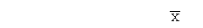= 0.47 + 0.49 + 0.41 + 0.48 + 0.27 = 2.12
= 2.12 = 0.42
5

Average density for method 2;
= 0.71 + 0.80 + 0.72 + 0.88 + 0.79 = 3.90
= 2.12 = 0.78
5

Average density for method 3;
= 0.42 + 0.40 + 0.35 + 0.45 + 0.26 = 1.88
= 1.88 = 0.38
5

Standard deviation (s) = √∑(x- )²
√ n-1

For method 1;
s = √∑(2.12-0.42)²
√ 5-1
= √0.7225
= 0.85

For method 2;
s = √∑(3.90-0.78)²
√ 5-1
= √2.4336
= 1.56

For method 3;
s = √∑(1.88-0.38)²
√ 5-1
= √0.5625
= 0.75

3) Confidence limits, μ = ± ts
√n
Where s is the standard deviation
t is the degree of confidence
For method 1;
50% = 0.42 ± 0.741x0.85 where t = 0.741
√5
= 0.42 ± 0.28
μ_{lower} = 0.42 - 0.28 = 0.14
μ_{upper} = 0.42 + 0.28 = 0.70

90% = 0.42 ± 0.76x0.85 where t = 0.76
√5
= 0.42 ± 0.29
μ_{lower} = 0.42 - 0.29 = 0.13
μ_{upper} = 0.42 + 0.29 = 0.71

95% = 0.42 ± 2.78x0.85 where t = 2.78
√5
= 0.42 ± 1.06
μ_{lower} = 0.42 – 1.06 = -0.64
μ_{upper} = 0.42 + 1.06 = 1.48

b) For method 2;

50% = 0.78 ± 0.741x1.56 where t = 0.741
√5
= 0.78 ± 0.52
μ_{lower} = 0.78 - 0.52 = 0.26
μ_{upper} = 0.78 + 0.52 = 1.30

90% = 0.78 ± 0.76x1.56 where t = 0.76
√5
= 0.78 ± 0.53
μ_{lower} = 0.78 - 0.53 = 0.25
μ_{upper} = 0.78 + 0.53 = 1.31

95% = 0.78 ± 2.78x1.56 where t = 2.78
√5
= 0.78 ± 1.94
μ_{lower} = 0.78 – 1.94 = -1.16
μ_{upper} = 0.78 + 1.94 = 2.72

c) For method 3;
50% = 0.38 ± 0.741x0.75 where t = 0.741
√5
= 0.38 ± 0.25
μ_{lower} = 0.38 - 0.25 = 0.13
μ_{upper} = 0.38 + 0.25 = 0.63

90% = 0.38 ± 0.76x0.75 where t = 0.76
√5
= 0.38 ± 0.25
μ_{lower} = 0.38 - 0.25 = 0.13
μ_{upper} = 0.38 + 0.25 = 0.63

95% = 0.38 ± 2.78x0.75 where t = 2.78
√5
= 0.38 ± 0.93
μ_{lower} = 0.38 – 0.93 = -0.55
μ_{upper} = 0.38 + 0.93 = 1.31

4) Determining the density of an object with dimension was obviously the most precise method of determining volume and it was the most preferred method for me. This is because the obtaining the mass and the volume of the various objects were relatively easier as compared to the other methods. All I had to do was to measure the dimensions (length, breath and height) using a ruler after which I took the product of these quantities to acquire the volumes of the five objects. The reading on the analytical balance gave the mass of the objects. The densities of the various objects were calculated by taking the mass to volume ratio.
Because the formula for calculating the volume of the regular solids was standardized, any error attained due to parallax would have minimal compared to errors obtained in the other methods.
5) The average densities of group 2 were unlike mine because of the different kind of wood used producing varying values in mass and volume of the objects. As a result, the mass to volume ratio produced different densities and thus dissimilar average densities.

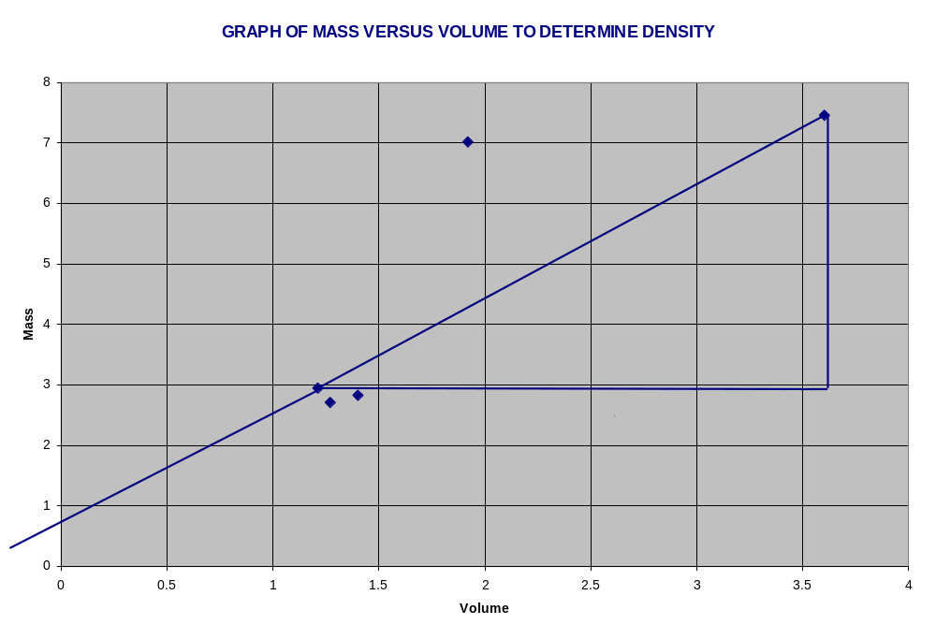
For method 1
Slope = ∆y = ∆m = (1.92 – 1.27)g
∆x ∆v (7.02 -2.71)ml
= 0.15g/ml
The graphical density was 0.15g/ml and that of question 2 was 0.42g/ml. Since the difference in the densities is quite appreciable, one can say that the calculated one is more precise.

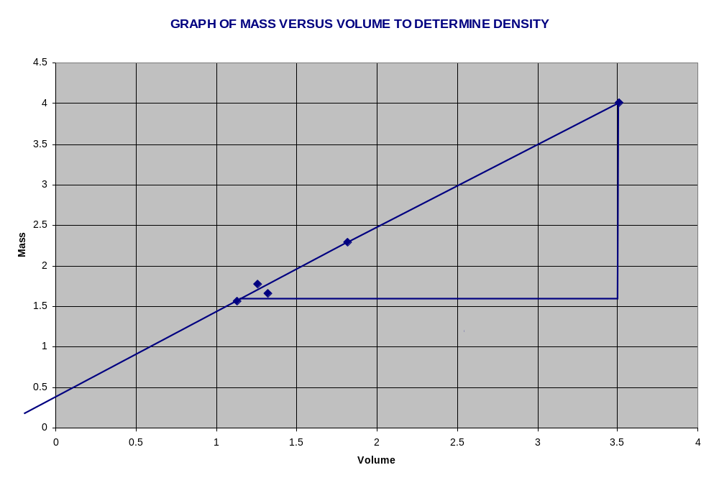For method 2
Slope = ∆y = ∆m = (1.82 – 1.26)g
∆x ∆v (2.29 – 1.78)ml
= 1.08g/ml

The graphical density was 1.08g/ml and that of question 2 was 0.78g/ml. Since the difference in the densities is quite appreciable, one can say that the calculated one is more precise.

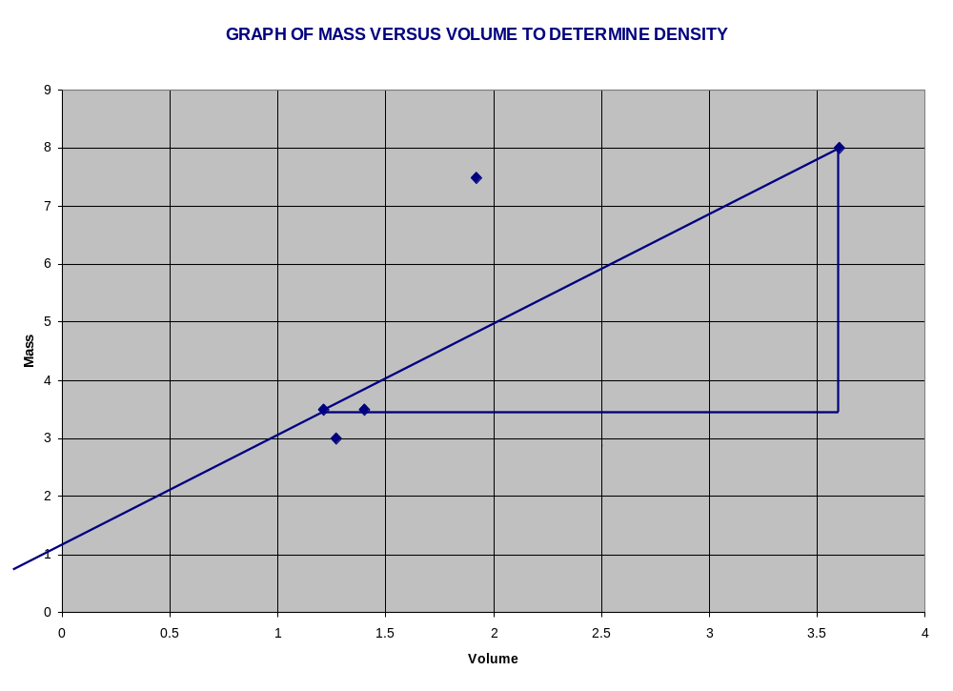
For method 3
Slope = ∆y = ∆m = (1.92 – 1.27)g
∆x ∆v (7.50 – 3.00)ml
= 0.14g/ml
The graphical density was 0.14g/ml and that of question 2 was 0.38g/ml. Since the difference in the densities is quite appreciable, one can say that the calculated density is more precise.

7) Advantages
- Because the graphical method defines precision of the experiment, it clearly spells out errors.
- The graphical representation of the experiment makes it much easier to predict the trend of the
- It is an easier way of obtaining values of densities without performing a series of calculations.

Disadvantages
- Drawing the line of best fit for experimental is quite difficult for data which is scattered as a result of error.
- Running of experimental values to suit a chosen scale contributes to errors.

8) Given that:
Mass of NaCl, M_{NaCl}= 3.5g
Mass of empty dry volumetric flask, M_{x} = 24.62g
Mass of the flask + dry NaCl, M_{y}= 27.60g
Mass of the flask + N-butanol + NaCl, M_{z} = 66.87g
Volume of the solution, V_{s}= 50 ml
Densities of N-butanol, ρ = 0.8098 g/ml⁻¹
Mass of N-butanol , M_{N} = M_{z} - M_{y}
= 66.87g – 27.60g
= 39.27g
Since ρ_{n-butanol} = M_{n-butanol} = 39.27g
V_{n-butanol} 0.8098 g/ml
= 48.25
M_{n-butanol} = 39.27g
ρ_{n-butanol} 0.8098 g/ml
= 48.49ml

Hence volume of NaCl = 50ml – 48.49ml
= 1.51ml

Ρ_{NaCl} = M_{NaCl} = 3.5g
V_{NaCl} 1.51ml

= 2.32g/ml

9) The NaCl density was more precise than the wooden object. This was due to the fact that, the volume was more accurately determined in comparison to that of the wooden object. The three different methods carried out in determining the densities of the wooden objects involved various procedures which increased the percentage error. For example, different dimensions, volumes and masses ad to be recorded before the actual volume, mass and density could be calculated. Precision was reduced because many approximations were made during the reading of values and when calculating.

10) The average experimental value NaCl value for the class is not coinciding with the accepted NaCl value. They differ by 0.15gml⁻¹

11) The accepted value for the NaCl density is 2.17gml⁻¹
Hence error = (2.32 – 2.17) gml⁻¹
= 0.15gml⁻¹

% error = true value – expected value x 100%
true value

% error = 0.15gml⁻¹ x 100%
2.17gml⁻¹
= 6.91%

DISCUSSION
It can be inferred from the definition of density that density is directly proportional the mass of the substance but inversely proportional to its volume. Thus as mass increases, density increases and as volume increases, density decreases. It was observed that the wooden objects were less dense than water.
After comparing the averages of experimental densities to the graphical densities were about the same. The graph was a scattered graph and thus a line of best fit was drawn for each graph.

SOURCES OF ERROR
- In determining the masses of the wooden objects, various approximations had to be made because of the unstable nature of the analytical balance.
- Upon transferring the NaCl into the volumetric flask, some got attached to the neck of the flask, thus not all the 3.50g of the NaCl was used.
- The 50ml volumetric flask was not exactly dry and so altered the values of the masses.

12) When you have a set of data with one data point that seems very different to all the rest, there must be a scientific basis for deciding whether to reject that point. You should not just throw it away without justification. If you have a series of repeated measurements of the same property, (e.g., viscosity, heat capacity ratio, surface tension, magnetic susceptibility, etc.), then the Q-test is a useful statistical way to determine whether one of your points in that series of measurements can be disregarded.
The Q is the absolute difference between the questioned measurement X_{q} and the next closest measurement X_{n} divided by the spread ω of the entire set of data.
Q = (X_{q} -X_{n})
ω
If Q is greater than the values for a particular confidence level, the measurement must be rejected. If Q is less than the values, it must be accepted.

PRECAUTIONS
- It was ensured that value reading that appeared the most was recorded for the respective objects
- All readings from the volumetric flask and cylinder were taken from the bottom of the meniscus.
- It was ensured that all bubbles were eliminated from the pipette from the pipette before taking the readings.
- All traces of water were wiped off from the volumetric flask and h cylinder before they were weighed as dry and empty.

ERROR ANALYSIS
- The woods absorbed water and this might have increased or decreased their masses.
- Error of parallax might have occurred whiles taking the reading from the meniscus or from the ruler whiles taking the dimensions.
- Fluctuation in the readings from the analytical balance.

CONCLUSION
On the whole the method of taking dimensions of a solid is used to determine the volume of regular shaped objects as well as their densities. The method of water displacement is used to determine the volumes of regular and irregular shaped objects and their densities.
The aims of the experiment were attained.

REFERNECES
- Chemistry Laboratory Manual, KNUST, page 33, 34.
- Introduction to Chemistry by Chopper and Johnson, pages 40-41.
- Essential Chemistry (Second Edition) – Raymond Chang – pages 430 – 439.

